**BANK LOAN REPORT QUERY DOCUMENT**

1. **BANK LOAN REPORT | SUMMARY**

**Key Performance Indicators (KPIs) :**

1. **Total Loan Applications**





1. **MTD Total Loan Applications**

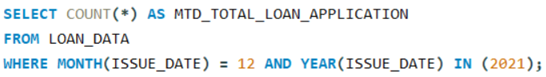



1. **PMTD Total Loan Applications**

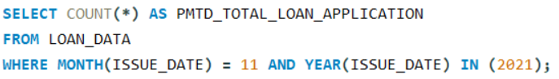



1. **Total Funded Amount**

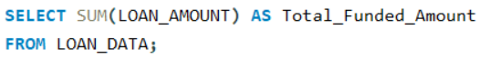



1. **MTD Total Funded Amount**

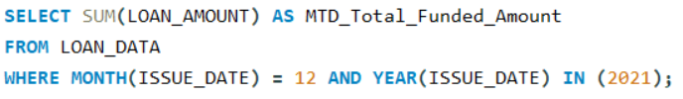



1. **PMTD Total Funded Amount**

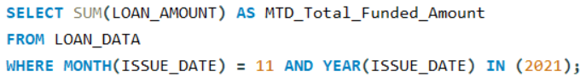



1. **Total Received Amount**

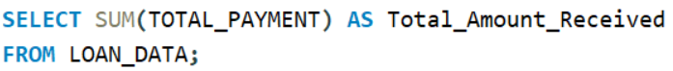



1. **MTD Total Received Amount**

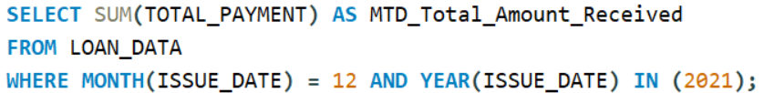



1. **PMTD Total Received Amount**

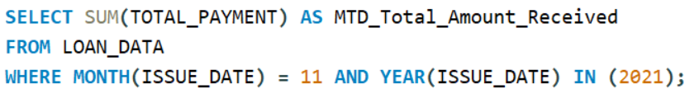



1. **Average Interest Rate**

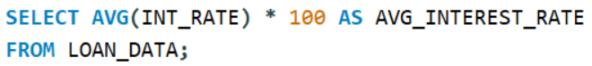



1. **MTD Average Interest Rate**

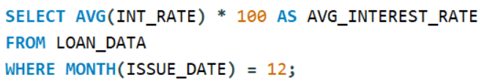



1. **PMTD Average Interest Rate**

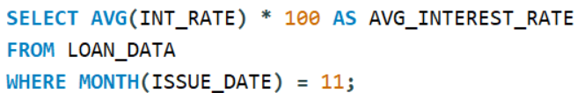



1. **Average DTI**

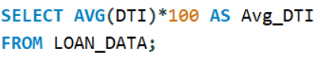



1. **MTD Average DTI**

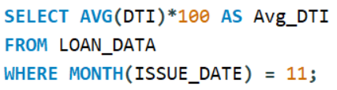



**Good Loan Issued :**

1. **Good Loan Percentage**





1. **Good Loan Applications**

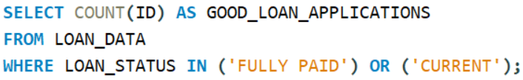



1. **Good Loan Funded Amount**

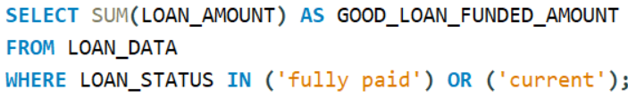



1. **Good Loan Amount Received**

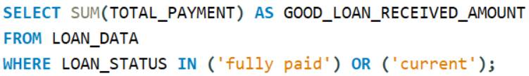



**Bad Loan Issued :**

1. **Bad Loan Percentage**

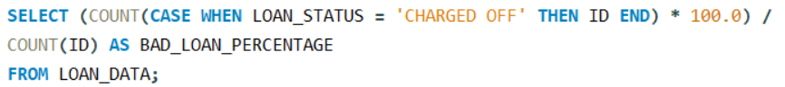



1. **Bad Loan Applications**

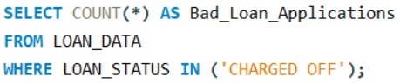



1. **Bad Loan Funded Amount**

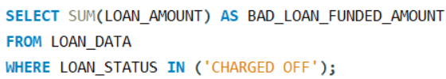



1. **Bad Loan Amount Received**

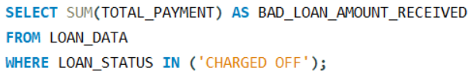



**Loan Status:**

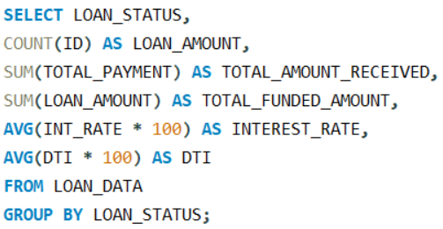

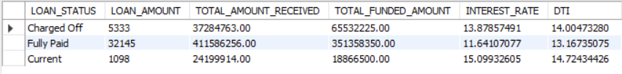

**MTD TOTAL AMOUNT RECEIVED AND TOTAL FUNDED AMOUNT BY LOAN STATUS**

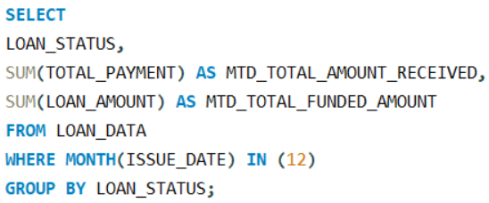

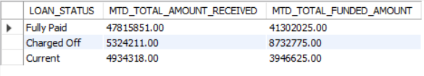

1. **BANK LOAN REPORT | OVERVIEW**

**MONTH**

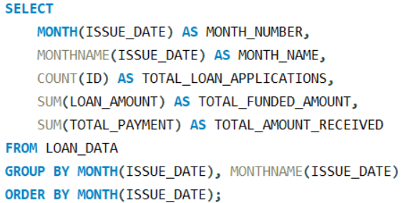

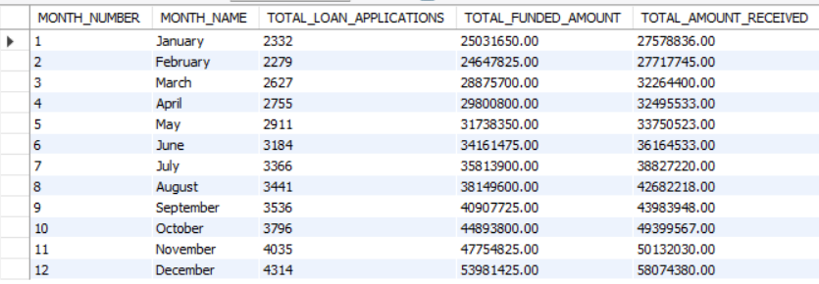

**STATE**

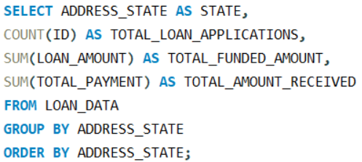

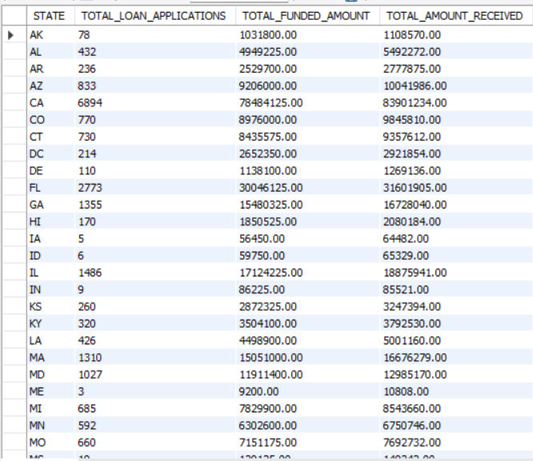

**TERM**

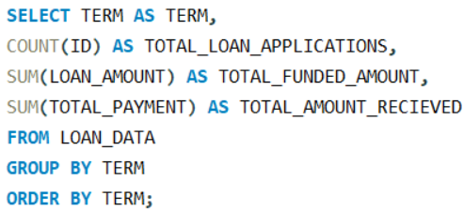

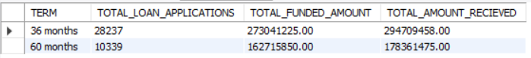

**EMPLOYEE LENGTH**

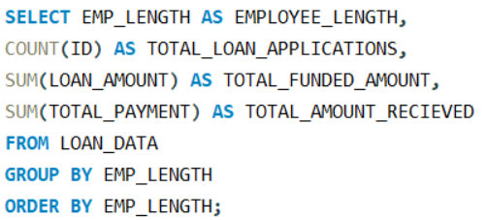

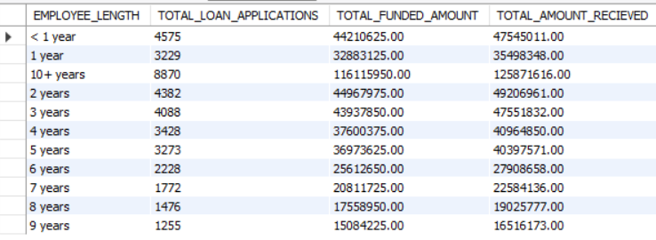

**PURPOSE**

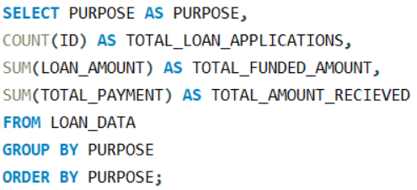

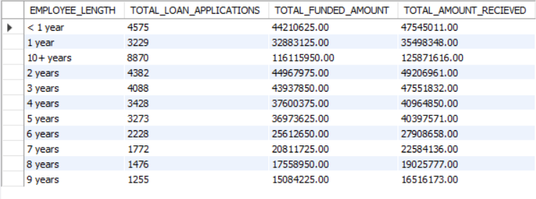

**HOME OWNERSHIP**

